Laparoscopic Roux-en-Y Gastric Bypass

M. Lakdawala, S. Goel, V. Lotwala

Introduction

The obesity epidemic has arrived in India. The menace of overweight and obesity in India has increased markedly over the past decade. While there is an agreement about the health risks of obesity, there is no clear agreement on its management. Treating obesity remains a problem because of the difficulty in maintaining long-term weight loss and of potentially negative consequences of the frequently seen pattern of weight cycling in obese subjects. Some argue that the potential hazards oftreatment do not outweigh the known hazards of being obese. Obesity, as a condition substantially raises the risk of morbidity from hypertension, type 2 diabetes, stroke, gallbladder disease osteoarthritis, sleep apnea, obesity hypoventilation syndrome and certain cancers viz: endometrial, breast, prostate, and colon cancers.

Overweight and obesity pose a major public health challenge. Not only is the prevalence of this serious medical condition soaring among adults, but is also affecting ever greater numbers of Indian youth. This would in most probability be due to current lifestyle and westernized food habits. In this report, overweight is defined as a BMI of 23.5 to 27.5 kg/m2 and obesity as a BMI of 27.5 kg/ m2, with morbid obesity above 37.5 kg/m2 the rationale behind these definitions is based on epidemiological data that show increases in mortality with BMI’s above 25 kg/m2. The increase in mortality, however, tends to be modest until a BMI of 30 kg/m2 is reached. For persons with a BMI of 30 kg/m2, mortality rates from all causes, and especially from cardiovascular disease, are generally increased by 50 to 100 percent above that of persons with BMI’s in the range of 20 to 25 kg/m2.

Treatment of the overweight and obese patient is a two-step process: assessment and management. Assessment requires determination of the degree of obesity and absolute risk status. Management includes both, weight control or reducing excess body weight and maintaining that weight loss to achieve control over associated risk factors. The aim should be to provide useful advice on how to achieve weight reduction and maintenance of a lower body weight. It is also important to note that prevention of further weight gain can be a goal for some patients. Obesity is a chronic disease, and both the patient and the practitioner need to understand that successful treatment requires a lifelong effort. There is a 98% recidivism rate with non surgical methods of weight loss at treating morbid obesity. The only currently available option at long term weight loss and control remains bariatric surgery.

Procedures

Weight loss operations can be divided into

- Restrictive procedures :Laparoscopic Adjustable Gastric Band
- 2 Vertical Banded gastroplasty
- Restrictive and malabsorptive procedures (gastric bypass)

Restrictive operations decrease food intake and promote a feeling of fullness (satiety) after meals. Malabsorptive procedures on the other hand reduce the absorption of calories, proteins and other nutrients resulting in weight loss. Some operations are a combination of both viz the gastric bypass

Lap Gastric Band Swedish Adjustable Gastric Band

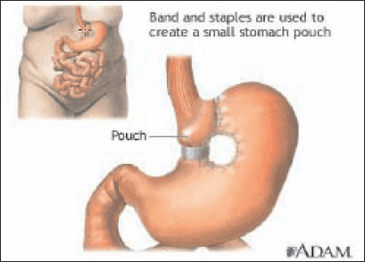
Vertical Banded Gastoplasty

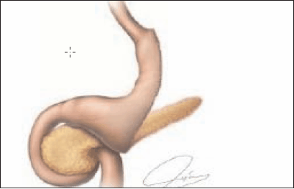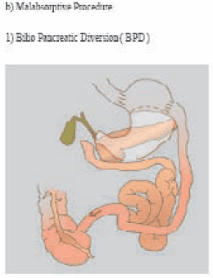
Sleeve Gastrectomy

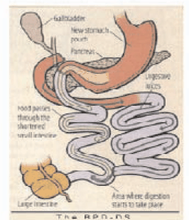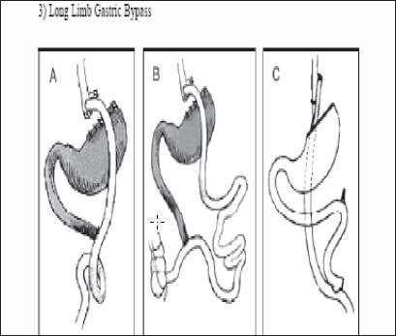

History

Early bariatric surgical procedures induced weight loss by malabsorption, i.e., by decreasing the absorptive surface of the intestine. Kremen et al performed the first intestinal bypass via jejunoileostomy in 1954, and Payne and DeWind performed a distal jejunocolonic anastomosis in 1956. These procedures were later modified by Sherman et al, 11 who sutured 14 inches of proximal jejunum in an end-to-side fashion to the terminal ileum 4 inches proximal to the ileocecal valve.

To avoid the high rate of complications associated with intestinal bypasses, Millroy developed VBG in early 1970s. Banding was developed by Wilkinson in 1978 to be modified by Molina in 1980 and subsequently redesigned by Kuzmak in 1983. Mason and Ito devised a gastric bypass procedure for morbid obesity in 1966, after noting the loss in weight that occurs after gastric resection for peptic ulcer disease. Initially, they transected the stomach horizontally and performed a loop gastrojejunostomy to the proximal portion of the stomach. Over several decades, the gastric bypass has been modified into its current form, using a Roux-en-Y limb of intestine (RYGBP).

The first use of the gastric bypass, in 1967, used a loop of small bowel for re-construction. Although simpler to create, this approach allowed corrosive juices from the small bowel to enter the gastric pouch, sometimes causing severe inflammation and ulceration of either the stomach or the lower esophagus. It was soon abandoned by its originators, in favor of less troublesome techniques, but has recently been employed again by a few surgeons, as the “Mini-Gastric-Bypass”, mainly to simplify the challenge of reconstruction, when performed laparoscopically. Although mini-gastric bypass has been asserted to have a low complication rate, there are now multiple reports in the medical literature of serious long term complications with the technique, necessitating major revisional surgery.

In 1994, Drs. Wittgrove and Clark reported the first case series of laparoscopic RYGBP. The primary differences between laparoscopic and open RYGBP are the method of access and method of exposure.

Higa and colleagues reported the largest laparoscopic RYGBP experience with 1,500 operations. There have been three prospective, randomized trials comparing the outcomes of laparoscopic versus open RYGBP. The largest trial was reported by Nguyen and colleagues in 2001.

Procedure Details

In the laparoscopic procedure, six small incisions are made, through which ports are inserted for abdominal access. Dissection is started at the angle of His. The Esophagogastric junction is on the left is separated from the spleen and left crus. The stomach is divided with laparoscopic staplers to create a 15-20cc pouch.
The ligament of Treitz is identified initially, and the proximal jejunum is divided approximately 50 cm distal to this point. A gastro jejunostomy is performed either handsutured, linear staplers or by circular staplers. The size of the anastomosis should be not more than 1.5 cms. A jejunojejunostomy is performed with laparoscopic staplers. A Roux limb of between 75 to 200 cm is formed depending on the BMI, and the jejuno-jejunal mesenteric defect is closed to avoid postoperative internal hernias. The Roux limb is placed in an antecolic fashion. The anastomosis is tested by gastroscopy for evidence of a leak after the procedure.

First transverse stapler between the first Retrogastric dissection upto left crus.
and second vessels on lesser curve

Vertical pouch of 30 ml. Tube to size anastomosis to 1.5 cms

Completed hand sewn gastro jejunostomy Stapled jejuno jejunostomy

Mesenteric defect closure to prevent hernia. Endoscopy to show presence or absence of leak at anastomosis.

Variations:

Silastic ® Ring Gastric Bypass

The Silastic® ring gastric bypass is a banded pouch RYGBP devised by Mal Fobi. A Silastic® ring is placed around the vertically constructed gastric pouch above the anastomosis between the pouch and intestinal Roux limb. The band controls stoma size by prevention of dilatation of the gastric pouch outlet, and is thought to provide better longterm control of the rate of emptying of the pouch and caloric intake. This procedure may also include placement of a gastrostomy tube for decompression of the distal stomach; a radioopaque radioopaque ring marker may be placed around the gastrostomy site to facilitate future percutaneous access to the distal stomach. A small percentage (3%) of patients may have band erosion or obstruction, necessitating reoperations and band removal. This procedure has better long term weight loss but higher morbidity from vomiting and poor tolerance to some types of food.

Advantages of RYGBP:

- Better weight loss than after purely restrictive procedures.
- Low incidence of protein-calorie malnutrition and diarrhea. As compared to purely malabsorptive procedures.
- Rapid improvement or resolution of weight-related comorbidities.
Disadvantages of RYGBP:

- Technically more demanding.
- Higher rate of complications compared to restrictive procedures.
- Takes longer to perform

A lot of debate as to the choice of procedure selection has been carried out over the last few years and many papers published. Recently Himpens et al published a report on the comparison of gastric bands versus sleeve gastrectomy over a 3 yr period. Weight loss and loss of feeling of hunger after 1 year and 3 years are better after SG than GB. GERD is more frequent at 1 year after SG and at 3 years after GB. The severity of complications appears higher in SG.

Dr Raul Rosenthal et al did a comparative study between bands and bypasses in over 1001 case and he found that excess weight loss was 51% at 6 months, 73.4% at 1 year for the gastric bypass group and 54% at 1 year for the laparoscopic banding group. The overall complication rate was 31.8% (12.4% major and 19.4% minor) in the gastric bypass group and 13% in the laparoscopic banding group.

Van Dielen compared bands versus VBG and inferred that despite better weight loss in VBG, based on complication rates and clinical outcome, LAGB is preferred. It had a shorter LOS and less postoperative morbidity.

A lot of debate has been undertaken on the open technique versus the laparoscopic method. An interesting paper in Obesity Surgery, 2004 compared the recovery time and outcome parameters.

Table 1. Recovery time following operations
 | Hospital days | Days to normal activity | Days to recovery
Open RYGBP | 3.5 (3-7) | 17.6 (7.42) | 29.1 (7.56)
 | (SD = 1.10) | (SD = 9.17) | (SD = 13.30)
Lap RYGBP | 2.5 (2.4) | 18.2 (1-60) | 21.7 (1.56)
 | (SD = 0.70) | (SD = 16.81) | (SD = 15.74)
Lap-Band® | 1.3 (1.6) | 7.2 (1.17) | 15.8 (1.30)
 | (SD = 1.11) | (SD= 4.35) | (SD = 8.95)

Table 2. Outcome parameters
Patient Group | Mortality1 | Major Cx1 | Conversion1 | OR Time2
Group A (n=75) | 0% | 8% | 2.7% | 122
Group B (n=75) | 2.7% | 13% | 2.7% | 189
Cx __ Complication, OR __ operative, OR times expressed as mean values in minutes.
1P = NS, 2P < 0.05

This paper also gave the morbidity as well as mortality rates higher in open compared to laparoscopy which led to the question of training in laparoscopy where A- is a trained Lap surgeon and B- untrained laparoscopic surgeon.
Jan Fay in 2004 published a comparative study on Band versus Bypass and gave the expected weight losses and results at the end of one year. He concluded that both LAGB and RYGBP are viable options with careful patient selection.

Complications of gastric bypass Early

- Anastamotic leakage

Leakage of an anastamosis can occur in about 2 to 3% of gastric bypass procedures, usually at the gastro jejunostomy site. A leak at the jejunojejunal anastomosis is rare. Sometimes a leak can be treated with antibiotics, and sometimes it will require immediate re-operation. It is usually safer to re-operate, if an infection cannot be definitely controlled immediately.

Besides pulmonary embolism a leak is the commonest cause of mortality in a gastric bypass and hence needs immediate attention. A delay in the diagnosis can often be fatal. The diagnosis of a leak is often confusing and needs a very high level of suspicion to pick up clinical signs such as tachycardia, tachypnoea, fever and raised wbc count. A Conray Study or CT Scan may sometimes be confusing hence if in doubt better to re operate and have a look than to conserve and repent later.

- Pulmonary Embolism

This remains one of the commonest causes of sudden death post bariatric surgery. Any injury, such as a surgical operation, causes the body to increase the coagulation of the blood. Simultaneously, activity may be reduced. There is an increased probability of formation of clots in the veins of the legs, or sometimes the pelvis, particularly in the morbidly obese patient.

Precautions

- Low molecular weight heparin
- Intra op calf pumps
- Early mobilisation
- Rarely IVC Filters

Late complications

- Anastomotic stricture

Majority of the strictures occur within the first month after surgery As the anastomosis heals, it forms scar tissue, which naturally tends to shrink (“contract”) over time, making the opening smaller. At most times it can be treated with a ballon dilatation of the stricture at gastroscopy, Sometimes this may have to be performed more than once, to achieve lasting correction. Stricture rates are highest with a circular stapled anastomosis (10%) especially with a 21 No. stapler.

b) Internal hernias

These usually occur through the petersons defect though the incidence has decreased with the ante colic approach. We prefer to close the jejuno jejunal mesenteric defect. Diagnosis is often difficult and a CT Scan may be diagnostic. If in doubt it is better to do a diagnostic laparoscoy.
Very rarely there can be a port site hernia.

c) Dumping syndrome

Normally, the pyloric valve at the lower end of the stomach regulates the release of food into the bowel. When the Gastric Bypass patient eats a sugary food, the sugar passes rapidly into the bowel, where it gives rise to a physiological reaction called Dumping Syndrome. An affected person feels his heart beating rapidly and forcefully, breaks into a cold sweat, gets a feeling of butterflies in the stomach, and has a “sky is falling” type of anxiety. He usually has to lie down, and is very uncomfortable for about 30 to 45 minutes. Diarrhea may then follow. The dumping syndrome is a response to a behavior which the patient should not be doing anyway: eating sugary foods. It is not life-threatening, and may assist one in making healthier food choices.

d) Nutritional deficiencies

- Hypoparathyroidism, due to inadequate absorption of calcium, may occur in over 30% of GP patients. Calcium is primarily absorbed in the duodenum, which is bypassed by the surgery. Most patients can achieve adequate calcium absorption by supplementation with Vitamin D and Calcium Citrate (carbonate may not be absorbed - it requires an acidic stomach, which is bypassed).
- Iron frequently is seriously deficient, particularly in menstruating females, and must be supplemented. Again, it is normally absorbed in the duodenum. Ferrous sulfate can cause considerable GI distress in normal doses; alternatives include Ferrous fumarate, or a chelated form of iron. Occasionally, a female patient develops severe anemia, even with supplements, and must be treated with parenteral iron.
- Vitamin B-12 requires intrinsic factor from the gastric mucosa to be absorbed. In patients with a small gastric pouch, it may not be absorbed, even if supplemented orally, and deficiencies can result in pernicious anemia and neuropathies. Sub-lingual B-12 appears to be adequately absorbed.
- Thiamine deficiency (also known as beriberi) will, rarely, occur as the result of its absorption site in the jejunum being bypassed. This deficiency can also result from inadequate nutritional suppliments being taken post operatively.
- B1 Deficiency because of constant vomiting may lead to Wernicke encaphelopathy.
- Protein malnutrition is a real risk in cases of long limb Roux-en-Y. Many patients require protein supplementation during the early phases of rapid weight loss, to prevent excessive loss of muscle mass and hair loss. A daily protein intake of 60 gms is required.
- Fat soluble vitamins A D E K need to be monitored.

Conclusion

Bariatric surgery remains the best available option for long term weight loss and control of co-morbid conditions in a morbidly obese individual.

Though the lap band remains a technically easy operation with an avg excess weight loss of 40 to 50% it should be reserved for a select group of very motivated young patients who are large volume eaters and willing to change lifestyle and exercise after surgery to achieve good results in the indian scenario.

The other purely malabsorptive procedures have limited options in India as the required protein intake after these surgeries may not be achieved with a predominantly vegetarian diet in india. Thus leading to complications such as protein energy malnutrtion or cirrhosis of liver. The advent of NOTES or Transendoscopic Surgery has opened up new horizons but the future benefits of these procedures need to be proved.

It is this scenario that the lap Roux-en-Y gastric bypass remains the procedure of choice in the indian context for dealing with morbid obesity and its co morbidities especially type 2 diabetes mellitus. Though needing a longer learning curve it is upto the surgeon to master this technique as this remains the gold standard of bariatric surgery in India.

