Laparoscopic Appendicectomy
M. G. Bhat
Appendicectomy is the commonest surgical operation performed and this may be done as an emergency or elective procedure. Laparoscopic appendicectomy (LA) was described in the early 1980s and has gradually become popular with the introduction of video laparoscopy. It is well accepted amongst the laparoscopic surgeons but has not gained the wider acceptance amongst the general surgeons. A UK audit published by the Royal College of Surgeons of England, in 1997 suggested that only 1.2% of patients undergoing appendicectomy had a laparoscopic operation1. A Recent analysis from the University Hospitals in the USA suggests a 20% increase in the utilization of lap appendix,2. The laparoscopic approach has many advantages1, 2, 3,4, when compared to open appendicectomy.
Indications
- LA is the operation of choice by experienced laparoscopic surgeons for all cases.
- Acute or chronic right iliac fossa pain with a doubtful diagnosis of acute appendicitis. Instead of laparotomy, a diagnostic laparoscopy, and appendicectomy will avoid unnecessary laparotomies, ^{4, 5, 6} and allow general visualization of peritoneal cavity.
- In young females where it may be difficult to differentiate other pelvic pathology from appendicitis.
- Obese patients who will require a large incision for open appendicectomy.
Pre Operative Preparation
Pre operative preparation and evaluation are the same as required for open appendicectomy and investigations are done according to clinical assessment. The possibility of conversion to open operation should be explained to the patient. Decompression of urinary bladder and stomach to minimise the risk of injury to these organs should be done as for other laparoscopic procedures.
Procedure
Laparoscopic appendicectomy is usually performed under GA with the patient in supine and steep Trendelenberg position. The surgeon stands on the left of the patient with the monitors at the foot end. Both upper limbs are placed by the side of the patient. After the ports are inserted, the table is tilted to the left, to make the right side up for help in the dissection.
Pneumoperitoneum
Is created by the open (our present choice) or Veress needle method and the 1st port (10mm), is ntroduced. Transumbilical entry is better and gives an excellent cosmetic result.
Diagnostic laparoscopy
Through the Umbilical port, a 10mm 300 telescope is introduced and a complete survey of the peritoneal cavity is performed. The 300 telescope gives more flexibility and wider view. The diagnosis is confirmed and the extent and severity of the inflammatory process is determined and feasibility of laparoscopic approach is assessed.
Secondary Ports
Two additional 5mm ports are introduced under vision. 2nd port, 5mm just above the symphysis pubis in the midline and 3rd port, 5 mm in the left iliac fossa (Figure 1). For better visualization of the operative field Trendelenberg position is maintained with left tilt of the table.
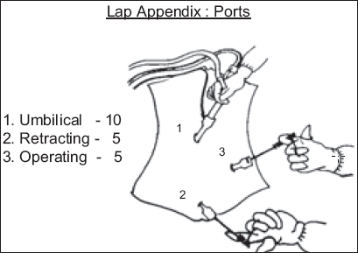
Figure 1

Dissection

A 5mm manipulator is used to assess the appendix, caecum, ileum, pelvic organs and the rest of the abdominal cavity. A non-toothed grasper is used through the 2nd port for grasping and retracting. The 3rd port is used for the main operation. The appendix is identified and mobilised in the operative field by dissecting the lateral and inferior peritoneal attachments. A retrocaecal appendix with adhesions will require mobilization of caecum and ascending colon. The mesoappendix is grasped at its tip with the non-toothed grasper and the appendix is elevated to visualise the mesoappendix fully (Figure 2). Any adhesions are released by endoscissors dissection with or without use of diathermy.

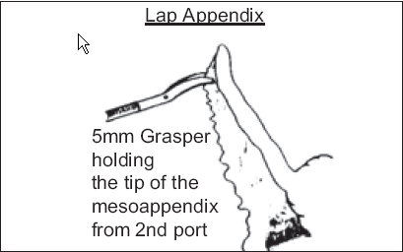
Mesoappendix

The mesoappendix is now cauterised close to the appendix with the use of bipolar grasper and divided with scissors. By repeating this procedure a few times the appendix is separated from the mesoappendix and dissected to the base. Bipolar cauterization allows specific tissue cauterisation and coagulates the appendicular vessels. This makes the procedure easy and cost effective. The appendix is now fully dissected and skeletalised (Figures 3, 4).

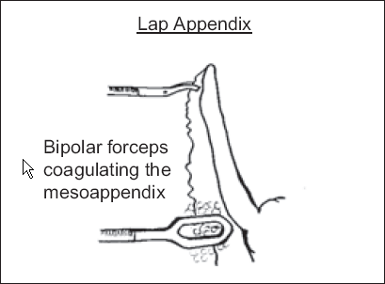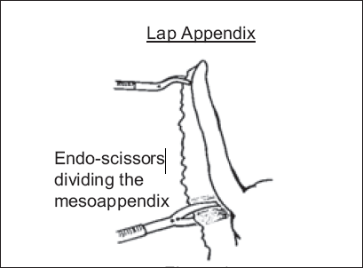
Figure 3 Figure 4

Ligation and Division of Appendix

The base of the appendix is doubly ligated with No.1 Chromic Catgut using a Roeder knot and pushing it with a knot pusher. A third ligature is placed on the appendix about 1cm away from the base ligatures and this ligature is kept long for further grasping of the appendix. The appendix is cauterised using bipolar forceps between the ligatures and divided. Use of ligatures adds to the cost effectiveness of the procedure (Figures 5, 6).

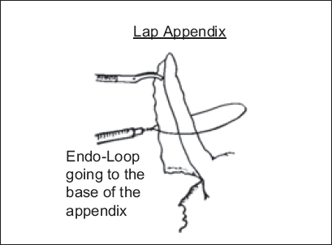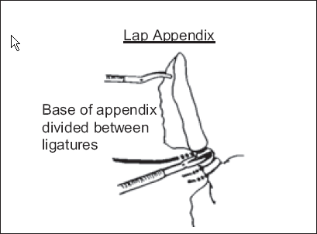
Figure 5 Figure 6

Delivery of the Appendix

The grasper holding the ligature on the appendix is pushed into the umbilical port.

By withdrawing the telescope and the port gradually this grasper is brought out of the umbilical wound. The appendix is then pulled out of the wound. If the appendix is distended and large, an endobag is used and the bag delivered in the same way. The use of bag prevents contamination of the wound. Irrigation of the area is usually not required (Figures 7, 8).
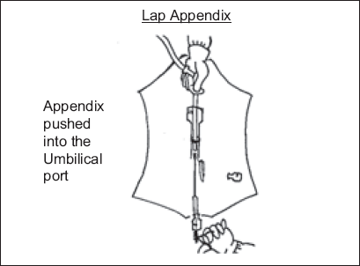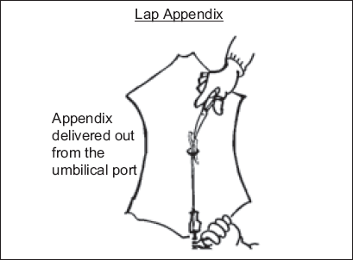
Figure 7 Figure 8

Closing the wound

The linea alba in the umbilical wound is closed with No.1 vicryl. The umbilicus is dressed with a gauze ball dressing without sutures to the skin. The other 2 wounds are closed with 3/0 Subcuticular Monocryl.

Intra Operative Problems & Solutions

There should be no hesitation to convert to open operation if there are any difficulties in performing the operation.

The conversion rate mentioned in the literature is 2 to 5 %, depending upon the experience of the surgeon. The Methods of solving following specific problems are described below.

- Mass Formation: Adhesion around the mass needs to be dissected gently with blunt or sharp dissection as in open surgery.
- Retrograde dissection. Initial identification and ligature of appendix base and further dissection.
- A loop ligature to the thick and inflamed appendix to hold during dissection. This solves the difficulties of holding the appendix in difficult cases.
- Mobilisation of the caecum and ascending colon for dissecting retrocaecal appendix.
- Perforation of the caecum at the base will require suturing the base with 2/0 vicryl.
- Bleeding – Gentle pressure, bipolar cautery, Harmonic Scalpel or suture the bleeder.
- Vascular Staplers for the Base of appendix and Mesoappendix is popular in the developed countries. This is much quicker and easier. May be useful in some selected cases. But it adds to the costs and is not necessary.
- In present day practice, there appears no need for Lap Assisted appendix operations.

Advantages of Laparoscopic Appendicectomy

- Complete evaluation of the abdominal cavity and definitive treatment of other and co-existing abdominal or pelvic pathology is possible without enlarging the incision.
- Return to normal activity is faster, with almost similar hospitalisation.
- Reduced post-operative discomfort and pain.
- Wound Infection Incidence is almost nil.
- Cosmetic results are better.
Disadvantages of Laparoscopic Appendicectomy

The only disadvantage is the marginally increased cost. There is an initial learning curve, which will increase the duration of surgery. Conversion to open surgery may be required in difficult cases.

Our Experience: Laparoscopic Appendicectomy

LA has been performed as a choice routinely in our unit. With experience we are convinced that it is superior to open procedure. The cost is comparatively higher than the open procedure but this is compensated by the advantages. Laparoscopic appendicectomies performed in our unit from 1993-2005 at Bangalore were audited. 403 available case records out of 460 lap appendix were analyzed. Diagnostic laparoscopy and appendicectomy for chronic right iliac fossa pain was performed in 40, appendicectomy for acute in 340 and elective appendicectomy in 23. There were 4 conversions to open method. In 1997 a prospective trial was conducted to compare the LA with Open appendicectomies. The comparison was between the different units in the department of surgery. The other units during that period only performed open appendicectomies and so there was no bias. 20 prospective consecutive cases in both groups were taken for the analysis. There was no significant difference in the duration of surgery or hospitalisation. LA was advantageous in diagnosis, pain relief, and quick return to work, reduced wound infection and cosmesis. The only disadvantage was the marginally increased cost. There were no complications. (Table 1 & 2)

Table 1
Laparoscopic Appendicectomy- 1993-2005 Analysis of data 403
Sex | M:F–22:28
Age(peak) | 21-40 - low: 7 high: 52
Duration | average- last 20/50 mts (High-2hrs, low-40mts)
Hospital Stay | average 3 days (High-9, Low-1)
Return to work | 1 week

Table 2
Lap & Open Comparison (20:20) (1997)
Operation | LAPAROSCOPY | OPEN
Diagnosis | 20/20 | 15/20
Anaesthesia | GA | GA/SP
Analgesia | 4 Days | 7 Days
Duration (in minutes) | 52 | 51
Hospital Stay | 3 Days | 4 Days
Return To Work | 7days | 10-12 Days
Wound Infection | Nil | 3
Cost (Average. Rs) | 11000 | 7000
Cosmesis | ++++ | 9cm Incision
Laparoscopy Appendicectomy as a Laparoscopy Training Tool

Appendicectomy, being a frequently performed procedure, it gives opportunity to teach surgeons in training with skills in laparoscopy. Laparoscopic Appendicectomy is being used successfully in many centers to train surgical residents and found to be a safe and effective laparoscopy training procedure7. The dissection, use of cautery and suturing can be learnt effectively.

Conclusion

Laparoscopic appendicectomy is feasible and with experience compares well and better with the open method. It definitely is preferable in young women with chronic right iliac fossa pain, in obese patients where a larger incision will be required, when cosmesis is preferred and for quick return to normal activities. It has become the choice of operation in laparoscopy centers.

References

- Memon MA: Laparoscopic Appendicectomy – the current status. Ann R Coll Surg Engl.1997;79: 393-402
- Nguyen NT, Zainanbadi K, Mavandadi B e all:Trends in Utilization and outcomes of laparoscopic versus open appendectomy. AJS. 2004;188:813-820
- Frazee RC, Roberts JW, Symmends RE et al: A prospective randomized trail comparing open versus laparoscopic appendicectomy. Ann Surg.1994 219:725-28
- Barrat C, Catheline JM, Rizk N, et al: Does laparoscopy reduce the ncidence of unnecessary appendicectomies? Surg Laparosc Endosc.1999;1:27-31
- Styrud J, Eriksson S, Segelman J, Granstrom L. Diagnostic Accuracy in 2,351 Patients Undergoing Appendicectomy for Suspected Acute Appendicitis: A Retrospective Study 1986-1993. Dig Surg.1999;16:39-44
- Moberg AC, Ahlberg G, Leijonmarck CE et al: Diagnostic laparoscopy in 1043 patients with suspected acute appendicitis Eur J Surg.1993;164:833-40
- Sai Prasad TR, Chui CH, Jacobsen AS: Laparoscopic Appendicectomy in Children: A trainee’s perspective. Ann Acad Med Singapore. 2006;10:694-7

Acknowledgments:

I thank my former resident Dr Arvind Shastry for the sketch diagrams in this article.

